Key Concepts and Workflow
Choosing the Azure Region:
  - Select the region closest to where the VM and associated resources will be consumed to minimize latency and maximize performance.
  - Azure offers numerous global regions; use the Azure portal’s interactive map to explore options.
Resource Groups:
  - Logical containers for grouping related Azure resources.
  - Two resource groups are created:
    - RG Jump – for the VM and related compute/storage resources.
    - RG Net – for networking resources like virtual networks and network security groups.
  - Resource groups can span multiple regions but best practice is to co-locate with resource regions.
Networking Setup:
  - Create a Virtual Network (VNet) in the same region as the VM.
  - Define an IP address range avoiding overlaps with existing networks (e.g., home or corporate networks).
  - Example: IP range set to 10.100.0.0/16 with a subnet named infra using 10.100.0.0/24.
  - Subnets allow creation of segmented network spaces within the VNet.
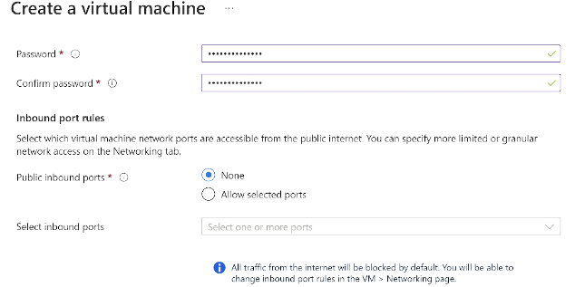
Network Security Group (NSG):
  - Used to enforce inbound/outbound traffic rules at the subnet or NIC level.
  - Created in the networking resource group and linked to the infra subnet.
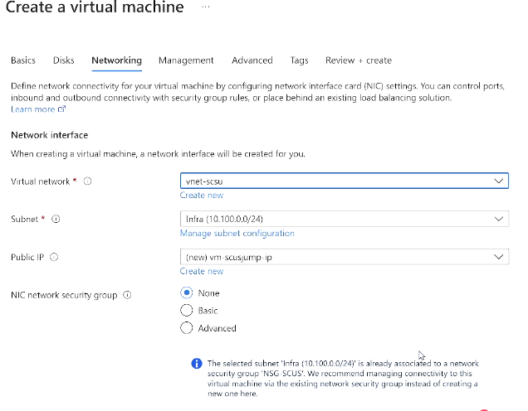
  - Custom inbound rule added to allow RDP (TCP port 3389) access only from a specific public IP (e.g., home IP) to improve security. If this is added in NSG from subnet level, we dont need to separately allow public inbound port while creating VM.
  - NSGs are best applied at subnet level rather than NIC level to avoid redundancy and complexity. So if we have NSG already at subnet, select “None” for NIC NSG.

Diagnostic Storage Account:
  - A storage account created to hold VM diagnostics data (e.g., logs).
  - Placed in the VM resource group (RG Jump), with standard locally redundant storage for cost efficiency.

VM Creation Details
Basic VM Configuration:
  - VM is created in South Central US, within the RG Jump resource group.
  - VM name reflects usage and region (e.g., vm-southcentral-jump).
  - Availability options: No infrastructure redundancy selected for a single VM use.
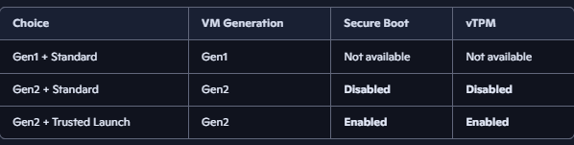
  - Security type: Default BIOS-based (standard) used; Gen 2 and Trusted Launch options available but not selected here. If you select Standard security (instead of Trusted Launch) while creating the VM, even with a Gen2 image: The VM will be Gen2 (UEFI-based, larger disk support, etc.). But Secure Boot and vTPM are not enabled — those require Trusted Launch. In other words, Gen2 hardware supports those features, but they are only activated when you choose Trusted Launch.
Operating System and Size:
  - Windows Server 2022 chosen as the OS image.
  - VM size selected as B2s (burstable VM) for cost-effective performance with CPU bursting capability, suitable for dev/test workloads.
Spot Instances (Optional):
  - Azure spot VMs utilize unused capacity at a discount but come with eviction risk if capacity is needed for pay-as-you-go customers.
  - Not recommended for critical workloads; ideal for batch jobs that can tolerate interruptions.
Authentication:
  - Username/password authentication for Windows VM.
  - SSH key authentication applies only to Linux VMs.
Disk Selection:
  - OS disk: Managed disk with standard HDD selected for cost-saving; options exist for premium SSD and ultra disks for higher performance.
  - Ephemeral OS disk option available for stateless workloads but not used here.
Networking Attachments:
  - VM connected to the previously created VNet and infra subnet.
  - A new public IP address is created automatically for remote access.
  - No additional NSG applied at the NIC level due to existing subnet-level NSG.
Management and Security Features:
  - Boot diagnostics enabled using the pre-created diagnostic storage account.
  - Guest OS diagnostics enabled for deeper insights.
  - Azure Defender for Cloud integration available for enhanced security (e.g., just-in-time VM access).
  - Managed identity option available for VM to securely access other Azure resources without storing credentials.
  - Auto-shutdown configured to reduce costs by automatically deallocating VM at a specified time daily.
Extensions:
  - Anti-malware extension added to the VM for basic protection.

Deployment and Post-Creation
Resource Creation:
  - Portal shows deployment progress and created resources in the resource group: VM, network interface, public IP, OS disk, extensions, and auto-shutdown task.
DNS and Connection:
  - Public IP configured with a DNS name for easier access (e.g., savotek-southcentral-jumpbox).
  - RDP connection file can be generated through the portal for easy remote desktop login.
Temporary Disk:
  - VM includes a temporary local SSD (D: drive on Windows) for page file or temp data.
  - Data on this disk is lost if VM is deallocated; not suitable for permanent storage.
Stopping vs. Deallocating VM:
  - Shutting down the VM from within the guest OS does not stop billing for compute resources; VM remains allocated.
  - Stopping the VM via Azure portal or command line deallocates the VM, stopping compute charges but retaining disk storage costs.
  - Auto-shutdown feature automates deallocation to save costs.
Cleanup:
  - Deleting the resource group removes all associated resources, preventing orphaned resources and unwanted charges.
  - Keeping resources organized in resource groups simplifies management and cleanup.

Core Insights and Best Practices
- Resource Grouping: Use separate resource groups for compute and networking to organize resources logically and simplify management.
- Networking: Carefully select IP address spaces to avoid conflicts and plan for future network integration.
- Security: Apply NSGs at the subnet level with restrictive rules tailored to your access needs; avoid open RDP/SSH from the internet.
- VM Sizing: Use burstable VM sizes (B-series) for cost savings in dev/test environments.
- Spot VMs: Useful for interruptible batch jobs but not for production workloads due to eviction risk.
- Cost Management: Use auto-shutdown and proper deallocation methods to minimize compute charges; always delete unused resource groups.
- Diagnostics and Monitoring: Enable guest diagnostics and consider Defender for Cloud for security and operational insights.
- Temporary Disk Awareness: Understand that temporary disks are ephemeral and should not store persistent data.

